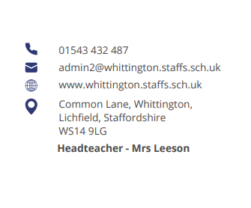



Parent Council (April)

Opal

Charlotte Russell updated the group on the big launch planned for 31 April. The program has been well received by the children and staff. Year groups have been missing and no accidents have occurred bar some scrapes and a head bump.
The equipment is easy to manage and store away.
Music is played at lunchtime and children are now outdoors 90%+ of the time.
A play session for parents, grandparents and carers is planned for 19 June.
An area on the school website is updated regularly.

Communication improvements

Members of the group fed back on comments and suggestions from their respective year group regarding communication formats and channels.
Discussion included the viability of a business WhatsApp for the school, an online calendar that can sync with family calendars and having all information, events and updates on the school website with prompts on X (Twitter).
It was agreed the school website would be the single source of truth and hold all information. The school can signpost all parents and carers to the website and reduce the number of texts and emails going forward.

Building work

During the Easter Holidays a new door will be built at the front of the hall with a secure system for The Nest drop off and pick up times.
In the summer holidays, new carpets will be fitted in the library and some main corridors.
Future work will include further carpeting and decorating and the KS1 playground wall.

Next meeting

1. Policy for lockdown
2. Pedestrian intercom for main gate and carpark

