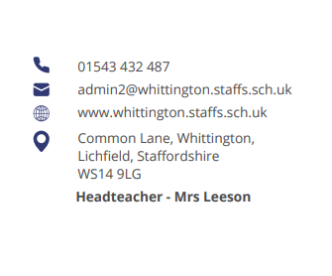



Parent Council (June)

- Updates from previous meeting: Internal decoration works start in the summer holidays, including flooring the library will be at the start of term over a weekend. The website will continue to be the main area for all updates on events and key dates that has been a good response rate to the annual questionnaire and the date has been extended.

- Feedback from Opal Parents session: Very positive feedback from parents and carers. Thank you to all who have volunteered their time and donated items As the weather changes in autumn and winter, the children will need waterproofs and wellies to enjoy the activities. Charlotte to circulate a mountain warehouse discount code for parents and carers to use if they choose to purchase. School to explore ways that parents could donate Old but usable waterproofs and wellies. The school has successfully applied to be featured in the charity token display within Tesco stores in and around the Lichfield area. Parents, carers and friends of the school are urged to vote as much as possible.

- School Council: Two members of the school council joined the group to discuss initiatives for the school year. These included the lunch menu a leadership booklet (also shared with other schools in the Academy) lots of positives with play buddies and reading mentors.

- Lockdown policy: Mrs. Leeson and Mrs. Jakeman showed the group the existing policy and walked through the practice sessions for staff and children. They are held once a term similar to the fire alarm practice. The policy cannot be placed on the School website for security reasons note the group has seen the lockdown policy.

- Parent Council arrangements for next year: The meetings will remain half term and representatives will continue to ask for feedback and comments from parents and carers. The school will make an appeal for New members ideally those with a pupil and reception class, year two and year six to ensure all year groups are represented. The Nests and Board of Governors will be invited to one of the future sessions.

- Suggestions for changes in the next school year: It was discussed whether having spellings circulated to parents and carers via email would be viable. School to explore option School also to look into whether book viewing days could be varied instead of just Mondays.

Date of next meeting Monday 6 October at 2 pm.

