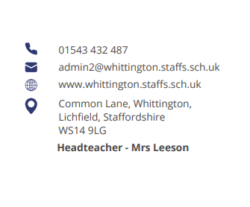




Parent Council Meeting

Monday 23rd June at 2pm

Agenda:

- Welcome and introductions

- Updates from previous meeting

- Feedback from OPAL parent’s session

- Meeting with School Council

- Lock down Policy

- Arrangements for next year

- AOB



