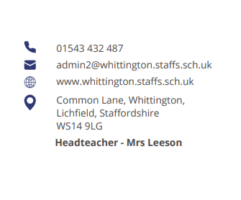

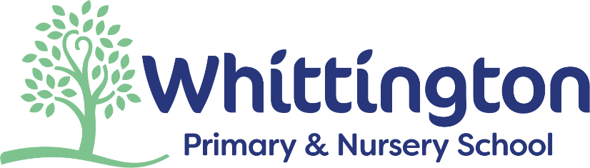


Parent Council Meeting

Monday 6th October 2025

Agenda:

- Welcome and introductions

- Actions from previous discussions:
- Calendar
- Panto
- Info about performances
- Work sharing evening

- Amy Hawkins – Early Years and Phonics

- Parent workshops

- School works update

- Items for next meeting

- AOB

Next meeting date:
- Monday 1st December at 2pm


