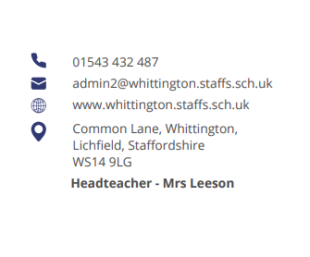




Parent Council Meeting

Monday 14th October at 2pm

Agenda:

- Welcome and introductions

- Our whole school priorities – presented by the School Council

- An introduction to OPAL

- Trips

- Ordering lunches with Yvonne

- Attendance incentives

- Items for next meeting

- AOB

Next meeting date:
- Monday 25th November at 2pm



