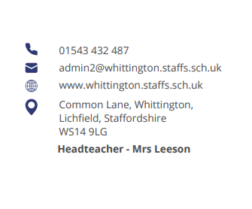




Parent Council Meeting

Monday 25th November at 2pm

Agenda:

- Welcome and introductions

- An update on OPAL (Charlotte Russell)

- An update on home-time changes for Y1/2

- Communication

- Service pupils (Emily Checkland)

- Items for next meeting

- AOB

Next meeting date:
- Monday 27th January at 2pm



