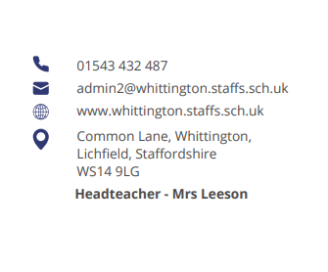



Parent Council (November)

Opal
Charlotte Russell updated the group on a recent visit from an Opal mentor where the playtimes were observed. 34% in self-scoring. interaction was good amongst children and there was no litter.
Another site visit on Monday 2 December to identify zones for possible enhancements. Next steps will be a site audit and budget/ fundraising. Items to be built, donated and sponsored. Risk assessments to be carried out. Live date February 2025 and an 18-month programme with constant feedback from the pupils.

Service Lead with Mrs Checkland
Mrs Checkland holds a pastoral position and works with Molly Nash (PLEASE CHECK SPELLING) the army welfare service at Whittington Barracks. Molly runs the after school club at the barracks and build links with the community.
Circa 20% of pupils at the school are in military families.
A service club is held at school each Tuesday lunchtime. Pupils bring a friend that’s non-military. They talk through emotions and changes with moving. Starting at school. Parents being away.
Events include ‘Wear Purple Day’ once a year in March.
The group discussed how this can be furthered. Mrs Checkland is planning to speak to other schools, service parents and carers and will feed back.
The school also focusses on any academic gaps identified when a child joins the school. Details on the Pupil Premium Strategy are available on the school website.

Year 1/2 end of day changes
Kate discussed the pick up procedure for children being collected on the field after school. Changes have been introduced to ensure children are released and not running out across the field.
Parents now gather on the playground and have an opportunity to speak to the teacher when needed. This will continue to be reviewed.

Next meeting

- Woodpeckers teacher
- Parent and carer WhatsApp groups
- Communication (teachers2parents) any alternatives.

