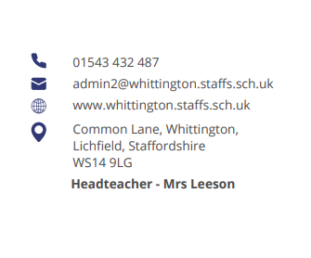




Parent Council Meeting

Monday 27th January at 2pm

Agenda:

- Welcome and introductions

- Updates from previous meeting

- Updates on OPAL

- JTMAT Parent Survey feedback – discussion

- Items for next meeting

- AOB

Next meeting date:
- Monday 7th April at 2pm



