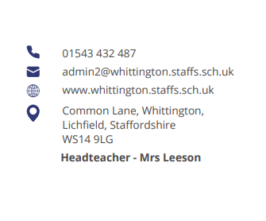




Parent Council Meeting

Monday 7th April at 2pm

Agenda:

- Welcome and introductions

- Updates from previous meeting

- Updates on OPAL since launch day/pupil views and feedback

- Discussion regarding communication improvements

- Update on building work

- Items for next meeting

- AOB

Next meeting date:
- Monday 23rd June at 2pm



