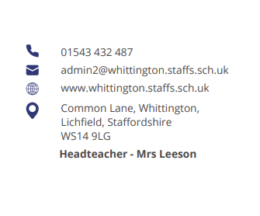



Parent Council (January)

OPAL

Charlotte Russell and Mrs Jakeman updated the group on the 18-month programme and confirmed it’s been a good start with the launch and appeal for donations.

It was agreed that further communications would be issued so a prioritised list of required items could be requested from sponsors and donors. Items and materials include:

- Lidded storage and sheds for storage
- A bike store
- Small world items
- Components for a stage
- Wheel play
- Dividers/ partitions/ nets
- Arts and crafts
- Lego station
- Mudslide messy café
- Sandpit
- Music wall
- Water play
- Fairy garden

Some local businesses have donated and others have pledged. Progression on the OPAL scheme will be updated on a regular basis. Thank you to all who have contributed.

JMAT Parent Survey Feedback

The school team fed back on the parent survey issued by JMAT in late 20024. It was reported the survey received a low participation rate.

Positives included homework and opportunities for enrichment.

Areas to be discussed further with parents and carers included:

- Best ways to receive school communications - currently not able to put all comms in one place. But the school could look into this at a cost
- Facilities/ cleanliness - decorating to be undertaken in school holidays
- Safeguarding - currently looking into converting a front facing window of the school hall to an intercom door
- Limited educational trips - looking at plotting from nursery to year six to then review overall
- Teacher absence levels (due to PPA, Leadership and CPD training) – the school has now established a roster of supply teachers to create consistency
- Behaviour - low level disruption is being escalated to Mrs Leeson and Mrs Jakeman and will be reviewed

Action – Parents and carers to make their Parent Council Representative aware of key grievances with communication. The council would like to have further details to then discuss further.

Next meeting:

OPAL
Parent/ carer communication

