
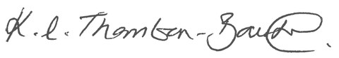

Physical Education:
Every Child
Every Week
Every Year
Physical Education: Every Child Every Week Every Year
Physical Education: Every Child Every Week Every Year Physical Education: Every Child Every Week Every Year
This is to certify that:

Whittington Primary School

has demonstrated outstanding commitment to improvement
in Physical Education, School Sport and Physical Activity

for the Quality Mark Award with
Distinction

Valid Until: 31st March 2028
Kate Thornton-Bousfield
afPE Chief Executive Officer

